**Project Document**

Connectly



Finn Habraken

Niray Mak

Dary van Sleeuwen

Nidhi Sharma

Edgaras Spiridonovas

Gijs Zwegers

**1.Start of the project** **4**

Project Debriefing 4

Brainstorm Process 5

Concept 9

**2. Design Process** **10**

App designs 10

Introduction 10

Colors and fonts 11

Pages 12

Logo 19

Sketches 19

Personas 24

Scenarios 27

Use cases 29

**3. Technical Documentation** **31**

Feature list / Requirements 31

Entity Relations Diagram 32

Architecture 33

**5. Personal Reflections** **34**

Niray 34

Gijs 35

Nidhi 36

Dary 36

Finn 38

Edgaras 39

**6. Peer Reviews** **40**

Niray 40

Gijs 41

Nidhi 42

Dary 42

Finn 43

Edgaras 45

# **1.Start of the project**

## Project Debriefing

**Clients:**

Olha Bondarenko - Eindhoven - [o.bondarenko@eindhoven.nl](mailto:o.bondarenko@eindhoven.nl)

Kees van den Broek - D-Centralize - [kvdb@d-centralize.nl](mailto:kvdb@d-centralize.nl)

**Company:** Fontys

**Project Description:**

In Eindhoven there are a lot of people from different places. A lot of people are not from around. They are here to study or work at brainport (ASML etc.). A lot of them don’t speak Dutch which creates a barrier.

Those people sometimes don’t really communicate with their neighbourhood residents.

Eindhoven is trying to involve residents to make decisions for neighbourhoods. A lot of people don’t even know Eindhoven is doing this. The app could help bring residents together.

Olha asked us to create an application that brings people more together. She gave us a few ideas of things that could bring people together.

1. People in her neighbourhood wrote messages on notes in the building to ask if they could help people doing groceries during the Covid-19 lockdown.
2. She organised an historic tour.
3. She organised a meeting where everyone brought their own food.

She also told us that it might be an idea to think about the Covid-19 lockdown. A lot of elderly people are afraid to go outside during this pandemic and feel lonely.

Olha would like us to think about what kind of problems are going on in neighbourhoods and how we can solve them using a mobile application.

Our task now is to research what is going on in neighbourhoods and come up with an idea how to solve one (or more) of them.

## Brainstorm Process

**Problem analysis:**

Most people (probably) are too scared to talk to random people

People don’t have (many) friends

**Improve neighbourhood quality**

- View of the neighbourhood

- Easily reporting crimes / damaged things to Eindhoven (broken benches / waste bins / traffic lights)

**Bring people together**

- Events

- BBQ

- Sports

- Party’s

- Hobbies

- Movie nights

**Helping people**

- Tasks

- Create posts for different tasks to do around the neighborhood

- If you are new and you have any questions you can post them

**Register people**

* Activities they like
* Requests/Events
* Schedule of open time slots for certain activity(eat outside, sports)
* Old and young people should be able use the application and understand
* Online approach (Neighborhood dance challenge, talent challenge, funny stories challenge).
* Track people around you (see only people in the certain range)
* chat group
* (App to register your information, pictures, activities you like, time slots you are available, make an events(sport activity, amount of people looking), be able to comment/contact, put location )
* Have an event which all neighbors do once a month, so the first saturday of the month is neighborhood night
* Put your skills in your profile. So when somebody needs a help with something they can search for somebody with the skill

**Our neighbourhoods:**

**Niray:**

*Negative:*

I recently moved to a studio in Eindhoven (Rapelenburg Residence). I joined the Facebook group and found out there are a lot of stolen bikes and scooters. I think the residence is responsible for finding a solution. They started building a new shed for bikes and scooters this week since the other one is full.

*Positive:*

There is a lot of green in my neighbourhood so that’s a good thing. I also think public transport is very good.

As earlier said, the residence I live in also has a Facebook group where activities are planned (BBQ, someone applied for a RGB project: <https://www.curvingtheflat.nl/>) which I also find great.

*Conclusion:* the greatest problem in my neighbourhood is probably criminality.

**Dary**:

*Negative:*

I live in a small village so I don't deal with these community and neighbourhoods problems.

*Positive:*

In my neighbourhood we have a lot of activities to keep the neighbourhood close. For example “Neighbourhood soccer day”. This is a soccer day on which a lot of neighbourhoods in my village participate. On this day each neighbourhood that participated is a soccer team and all the neighbourhoods play against each other. Eventually you reach the finals etc. and one neighbourhood team is the winner. Everybody in their neighbourhood can join their team. Even the ones that don’t even play soccer so it’s very fun because there is a broad mix between good and bad players which leads to funny matches.

Furthermore we as a neighbourhood plan a couple of events every year. One of them is the “Neighbourhood day” as we call it. Neighbourhood day is a day where we do fun things with all the people in our neighbourhood such as having a barbecue and all the kids play together etc. Also we have a big neighbourhood whatsapp group chat. For example when new people move into the neighbourhood someone sends a message in the group chat so that everybody knows there are new people. That way the new people are quickly introduced. The group chat is also used to keep the neighbourhood safe. So whenever something suspicious happens someone can send a message about that so that everybody is informed. Also some people try to keep our neighbourhoods safe. So has someone put down a safety sign next to the road that warns people that little kids might be playing in the neighbourhoods of streets. This makes the people aware not to drive too fast or violate the speed limit.

**Gijs**

*Positive***:**

I live in a small village with my parents, sister and brother. We have a neighborhood community that is very active. I like that they plan a lot of activities. For example, with easter we go easter egg searching in a huge garden from someone in the neighborhood. Our neighborhood is clean of trash and if there’s something weird happening we have a neighborhood whatsapp group where we can report it in.

*Negative***:**

I live next to the end of the bus station and there is a big parking lot where people can wait. Sometimes there are people late in the night when there’s no bus riding anymore. I think it would be better if we place a lantern or something there so it would be more visible.

**Nidhi**

*Positive:*

I live in a studio in Eindhoven in a building full of students and working people. My neighbourhood is surrounded by greenery and there is a church right next to it. I live right behind the university and it’s a five minute walk from the public transport. Our neighborhood is very clean and if anything is happening we have a group on whatsapp where we talk about it. We have a huge backyard at the back where we had a BBQ event once. Usually some of us go there to chill and spend time with our neighbors.

*Negative:*

We don’t really have an active neighborhood. It took me 1 year to actually meet my neighbours. Then I was added to the whatsapp group where it consists of only ten of my neighbours in the entire building. We only had one event where I met all of them and after that we would only greet each other in the hallways. The bike shed is always full of bikes and there is no space, so some people would have to park their bikes right behind the door of the building. We have a big parking space and cars come in day and night, and sometimes people make too much noise late at night which is disturbing for all of us.

Conclusion

I think we need to be more active as a neighborhood community and actually get to meet and know everyone in the building rather than just ten of us.

**Finn**

*Positive:*

There were annual neighborhood BBQ’s hosted by the people that live in my neighborhood. These were always pretty fun, and the organizers would always get a bouncy castle or something to make it more enjoyable for the kids.

*Negative:*

Since all the kids in my neighborhood grew up, we aren’t as close, and barely see eachother anymore.

The brainstorming method we used was mind mapping. We first came up with our own ideas of what we think the application should have. Then using this method we came up with some features we want to have in the app.

Mind Map:

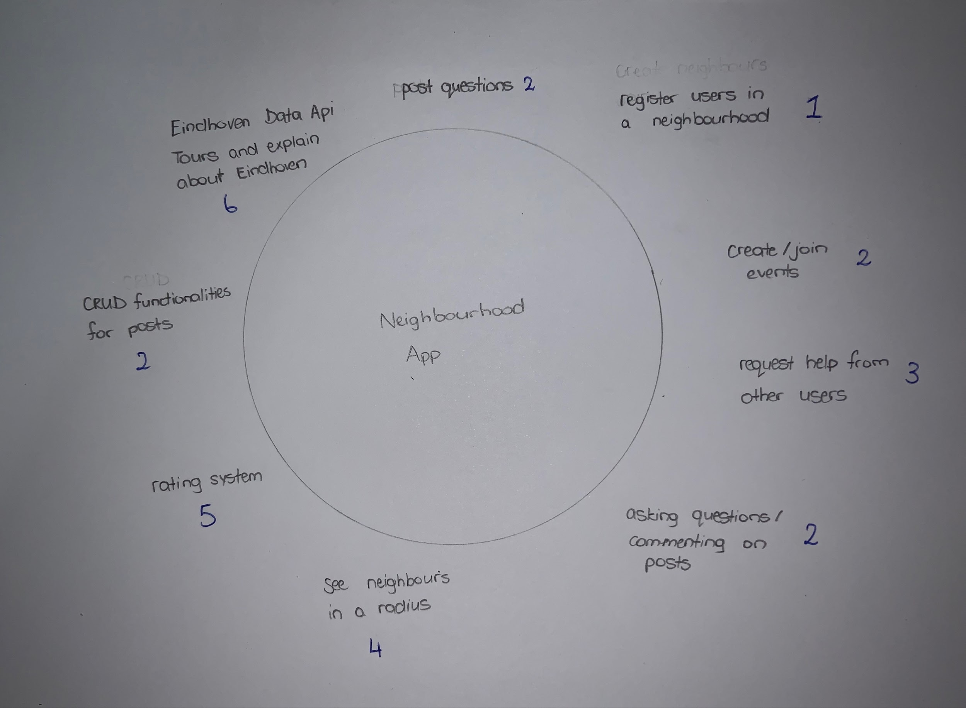

## Concept

We would like to make an application where users can register themselves in a neighbourhood and get to know their neighbours better. In this app, users can create or join events with others. When the users register they mention their information and say how long they are living in that neighbourhood which helps other users as well.

We are also thinking of extra features for the app which will be optional incase we have a shortage of time: You can see the neighbours in a radius of 500m-2km and which countries they belong to. We would be using no sql storage for the users events.

After our first client demo we decided to focus on the more specific functionalities of the app:

* Creating, joining and leaving events
* Focusing on new habitants
* Chat Group for event
* Tips to help communicate better for every nationality
* Events can be linked to locations (such as playground or the park for picnicking etc.).

# **2. Design Process**

## App designs

### Introduction

We used an orange / dark gray color scheme for the buttons and other clickable objects and and Product Sans font for the text and input boxes. We tried to use a lot of material design in our app and sometimes made our own version of it. In the whole design process we have looked how material design handles different situations and designs. We also used some material design icons.

### Colors and fonts

### 

### Pages

### 

### 

### 

### 

**Login page**

The first thing we made was the login page. We used the orange input boxes and a login button below it. In between we added a ‘forgot your password’ button. On the bottom we added a ‘sign up’ button, that leads to the signup page in case you don’t have an account yet.

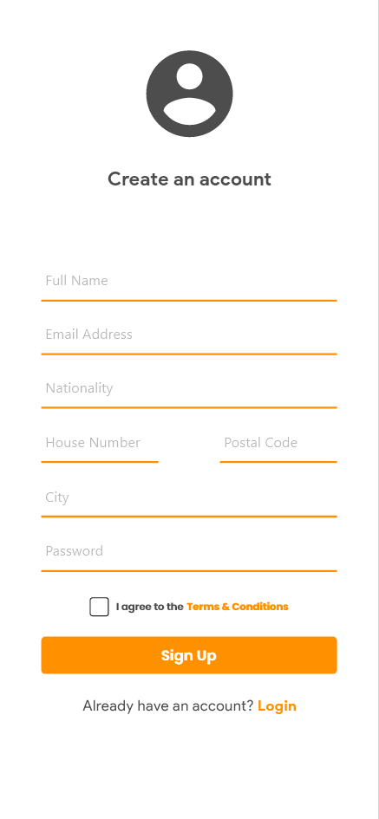

### 

### 

**Signup page**

For this page we also used orange input boxes for all the information. Below the form is a ‘terms and conditions’ button that currently doesn’t lead anywhere, but should have a use in the future. Below this is the big orange ‘sign up’ button. In case you didn’t mean to go to this page, you can also go back to the login page by clicking on the button on the bottom of the page.

### 

### 

### 

**Homepage**

After signing in, you will be greeted by the homepage. On this page you can see your name and picture on top. Below this is a day-slider, where you can decide for what day you want to see the available events.

The events part of this page consists of a category filter at the top right, and underneath that is the list of currently available events for this day. All the way on the bottom we made a navbar, that you can use to navigate to your account, the create event page and back to the home page.

# 

## 

## 

**Eventpage**

After you click on an event on the homescreen, you get redirected to this page. At the top of this page you can see a picture of the activity and the title. Below this is the date and time, and one line later you can see the location. After this part there is a short description of the activity.

At the end of the information form you can see how many different nationalities are going to this activity, and how many people are going in total. At the bottom of the page there is a button to confirm you’re going and a ‘not interested’ button that will redirect you to the homescreen.

## 

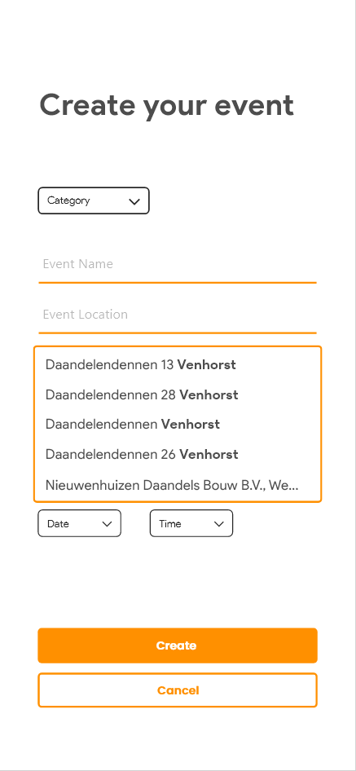

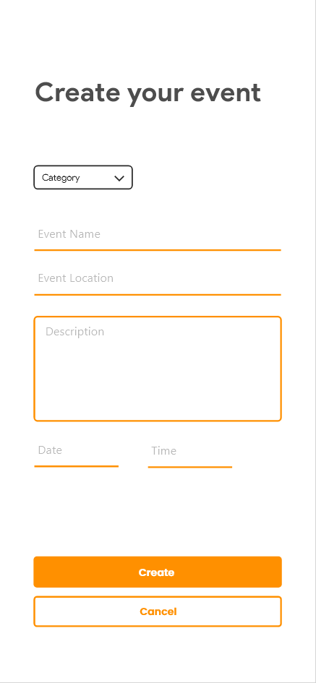

## 

**Event creation page**

if you click on the plus button on the homepage you get directed to the event creation page. On this page you can create an event with the the specific information. You need to set the category, event name, location, date and time but the description is optional. Of course you can confirm everything and create the event with the create button.

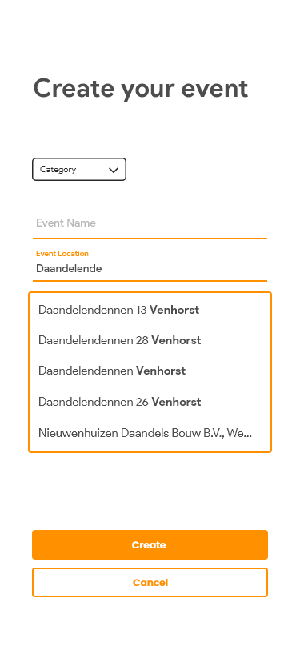



**Location suggestions**

Once you type something in the Event location input box the app gives you suggestions of which locations your might mean based 0n what you have already typed in.

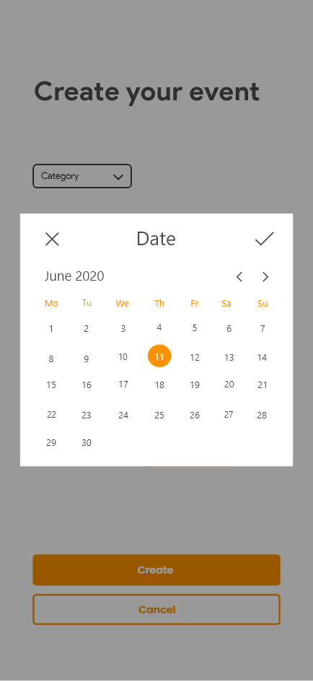

## 

**Event creation - date picker**

When you click on the Date input this popup will appear. With this popup you can set the date for the event. You select a date by clicking on a day number. You can slide horizontally to go to the next month. Once you have selected your date you can confirm your date with the check button.

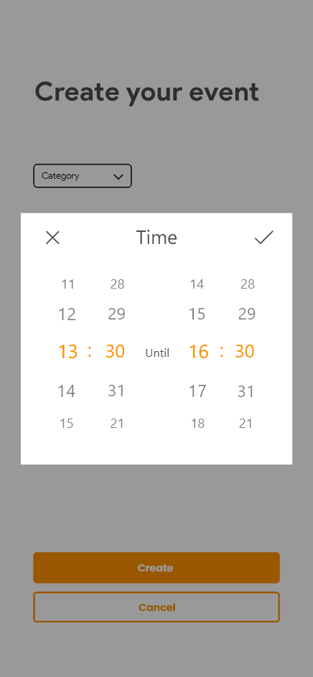

**Event creation - time picker**

The same applies when you click on the Time input. With this popup you can set the time bij scrolling on of the four vertical time sliders. And again you can confirm you choice by clicking the check button.

## 

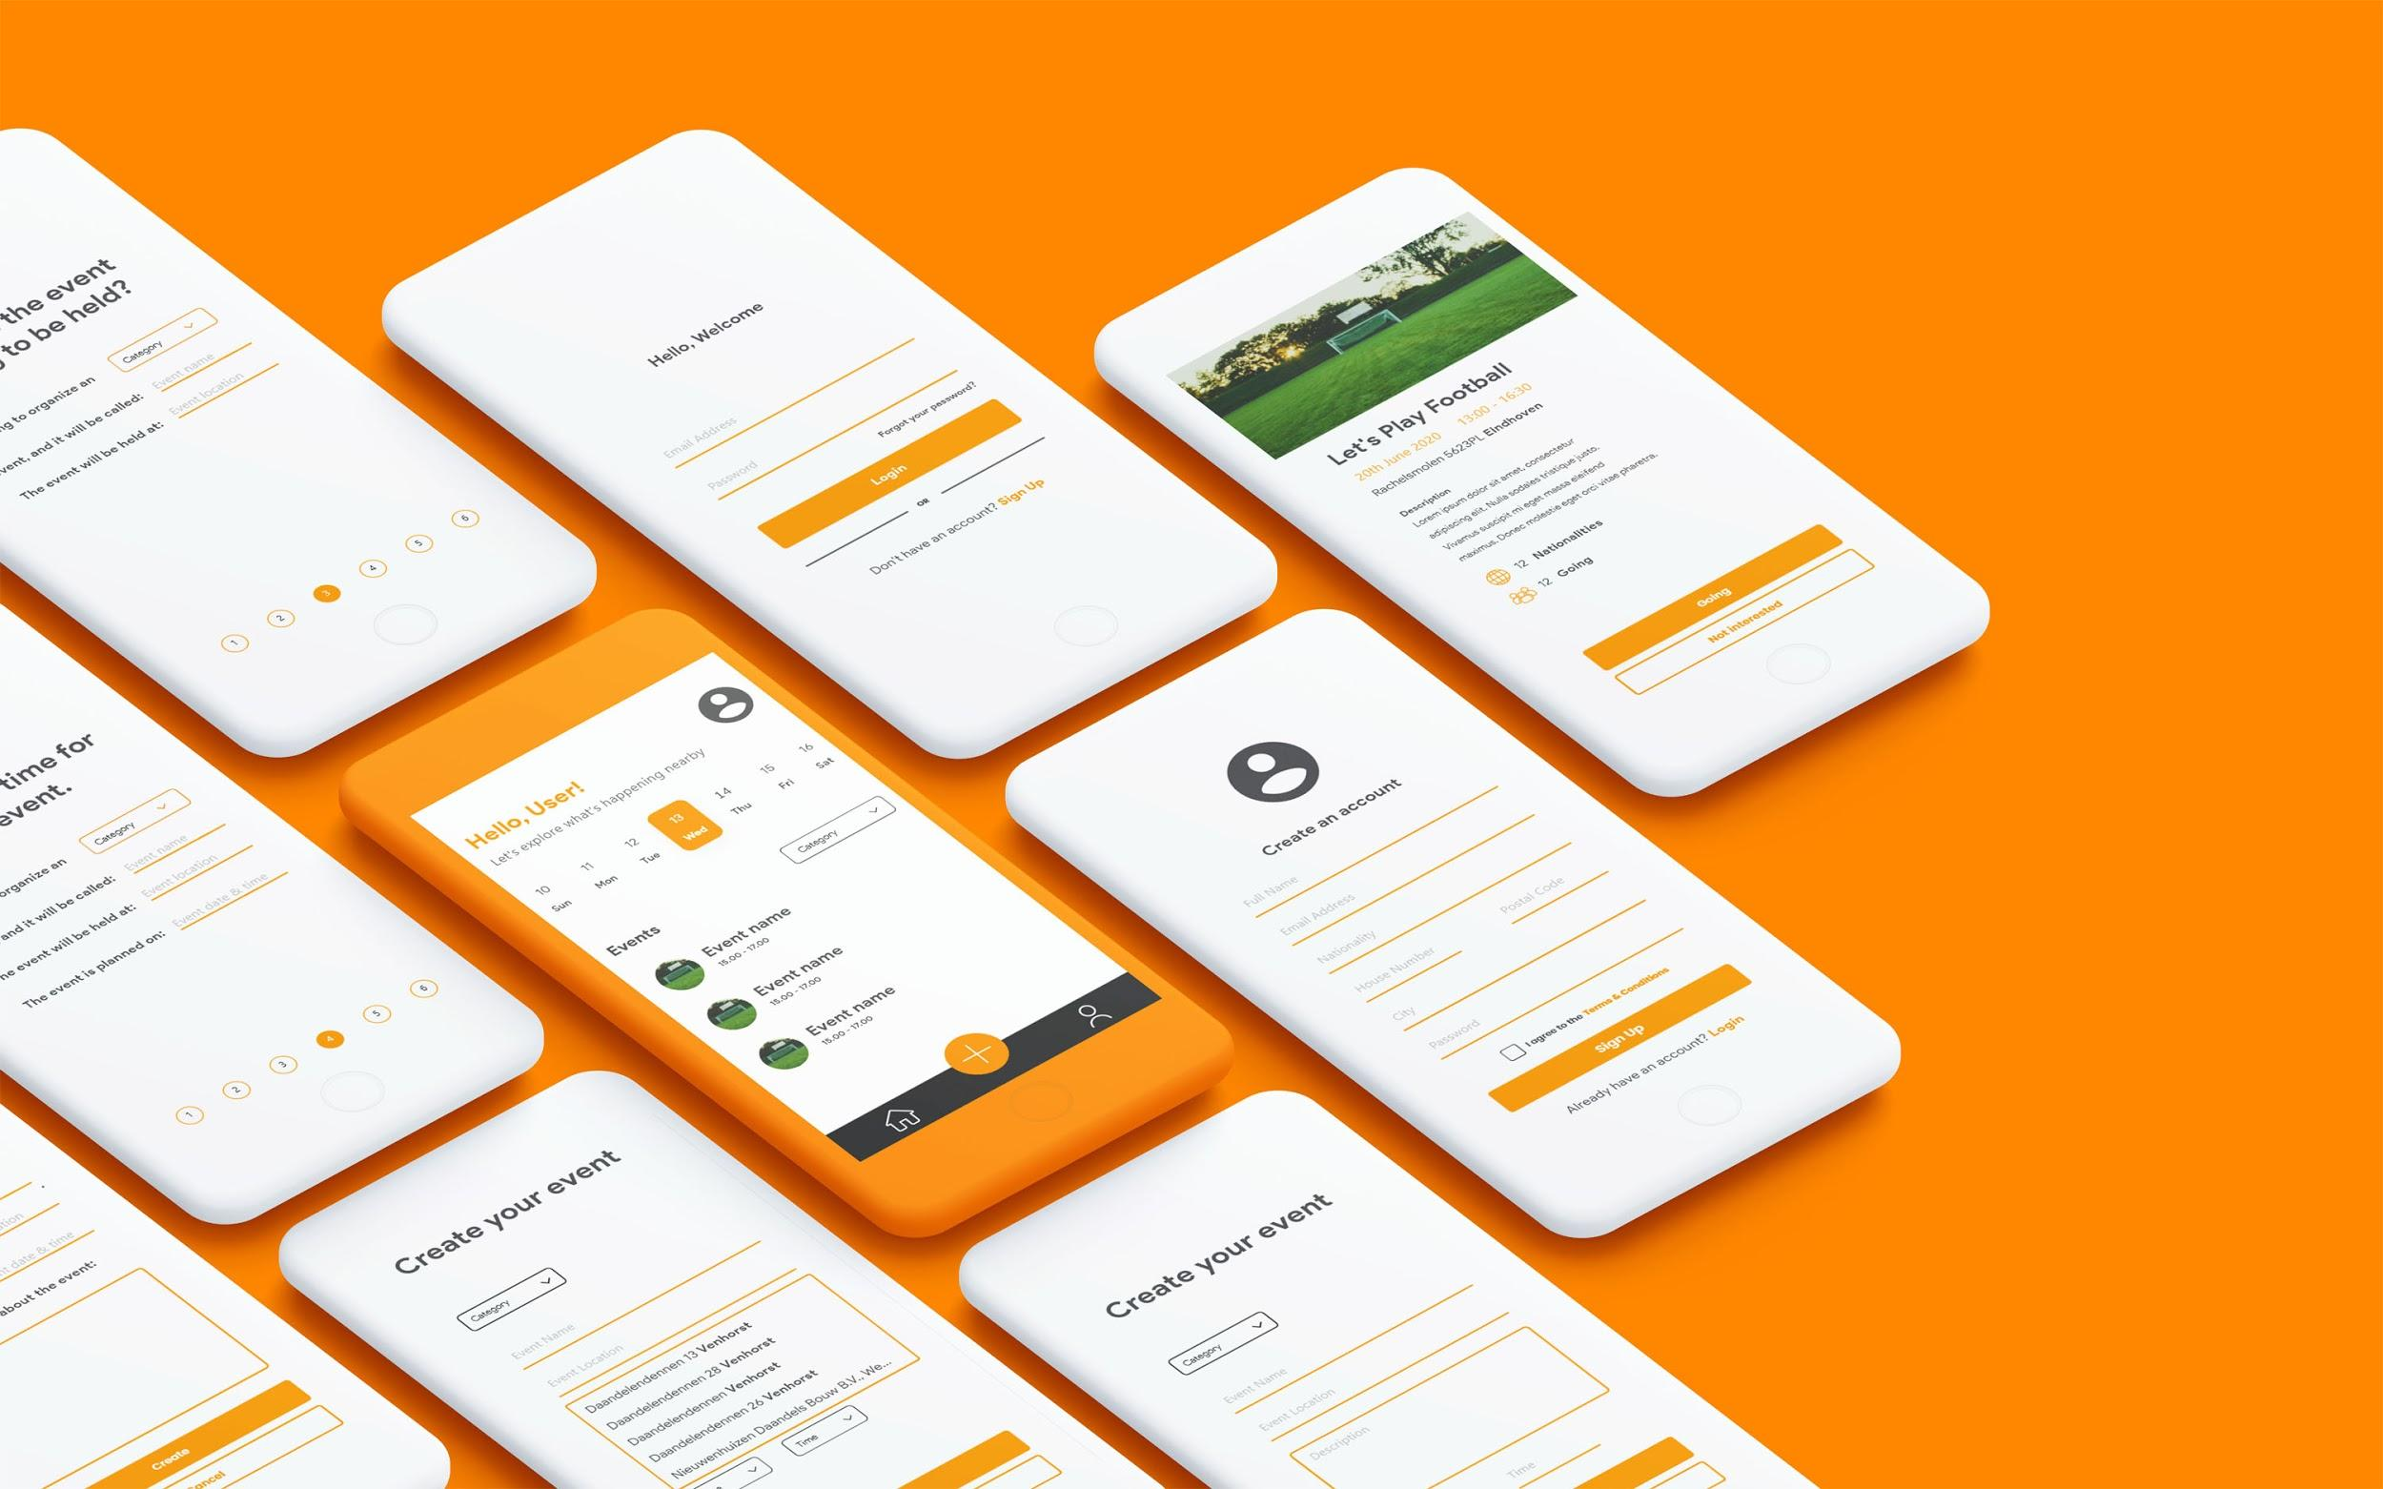

# 

## Logo

### Sketches

We didn’t really know where to start with the logo design, because we didn’t really have a clear plan on what kind of logo we wanted. Therefore, we decided we were gonna make a bunch of very simple but different logos, so we could get some inspiration for an end result.

**Sketch 1**

For the first sketch we decided to make a big round circle with an opening to the right, to make it look like a ‘C’. In that gap we placed the letters LY capitalized. We decided to go for a complete monotone color scheme, with dark gray as the only color used.

The circle symbolizes a circle of friends (which is what our app tries to achieve), and the opening to the right symbolizes being open minded to different cultures.

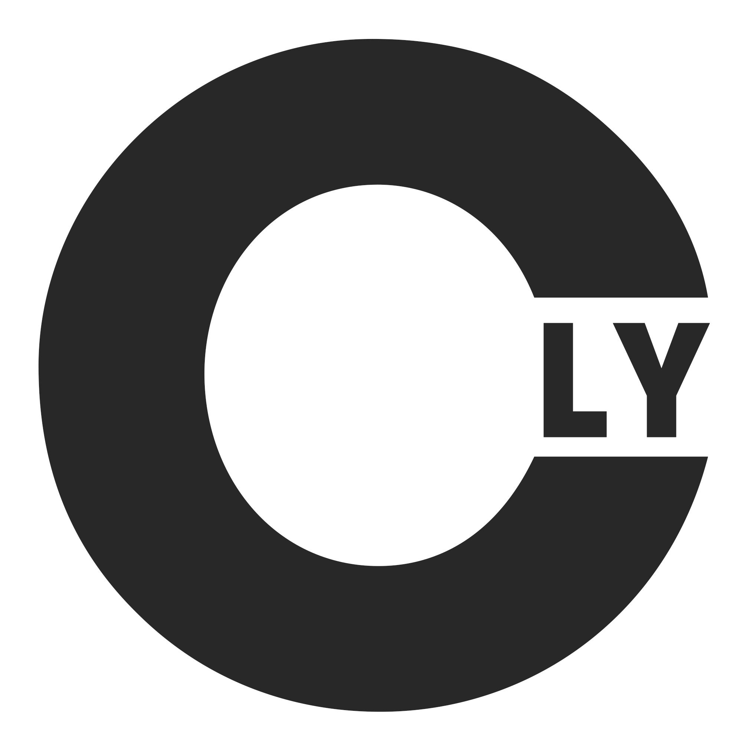

Eventually we decided that this logo was a little bit too boring, so we scraped it and went on to the second sketch.

**Sketch 2**

For the second sketch we wanted to incorporate our color scheme for the app a little more. These logos are both relatively simple. For the left one, we just typed the word ‘connectly’ in the ITC Avant Garde font, and colored the ‘l’ and the ‘y’ in our orange color. We also made a shorter version (on the right), but quickly decided to scrap that in favor of the left one.

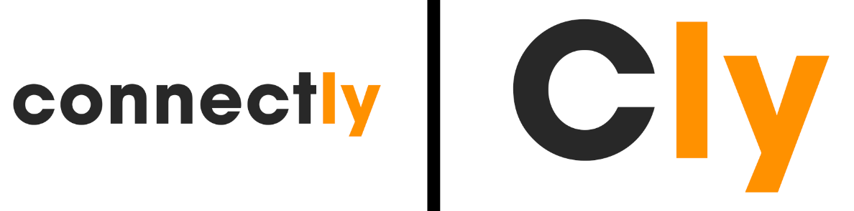

We weren’t going to use just the text on the left as a logo, but it would turn out to be a good subtext for our more compact logo in the end.

**Sketch 3**

The third sketch started out as a variation of the previous one. This time however, we seperated the ‘ly’ from the rest of the word, by putting it half below ‘connect’. To give it something extra, we added a line of the same thickness as the rest of the font below the top part.

After this we created a second version, where we colored the lower part of the logo orange, to distinguish it from the upper part. The problem with this version was the fact that the ‘l’ didn’t really look like one anymore, and instead looked like part of the line to the left of it.  
To counter this problem, we made a third version where we separated the line from the ‘ly’, to make sure it doesn’t blend together.

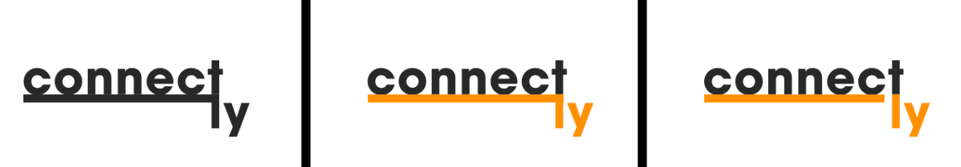

This logo was not very compact however, which is why we decided not to use it as our final result.

**Sketch 4**

This sketch started of with the logo that we made for the second sketch. We wanted to add something on to that logo to see how it would look. After a bit of thinking we went with a signal icon above the ‘o’, to symbolize the ‘connect’ part of our name. We made 2 circles around the ‘o’, and removed the lower part of these circles, so that the radar design came together pretty well.

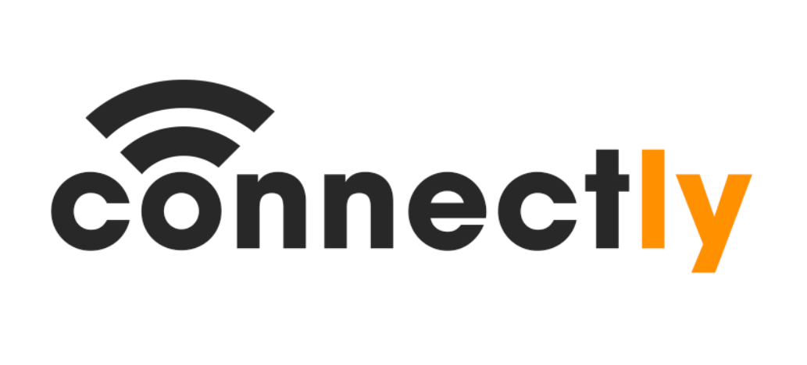

In the end we decided not to use this logo, but it did give us some inspiration for our final logo.

### Final Versions

#### Version 1

Our fifth and final sketch started of with a C around a dot in the middle. We surrounded this C with a circle. This way we would have a C incorporated into a compact logo, which is the idea we went for here.

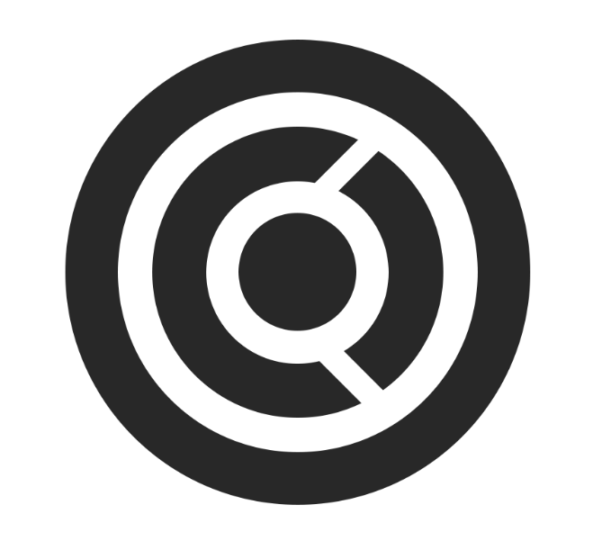

This logo did not feel complete however, so we decided to experiment a bit more with it. which is why we decided to color in the C. This logo felt complete as soon as we extended the white opening to the outer ring, to make it look like a signal came out of the C, which of course fits perfectly with the name ‘Connectly’.

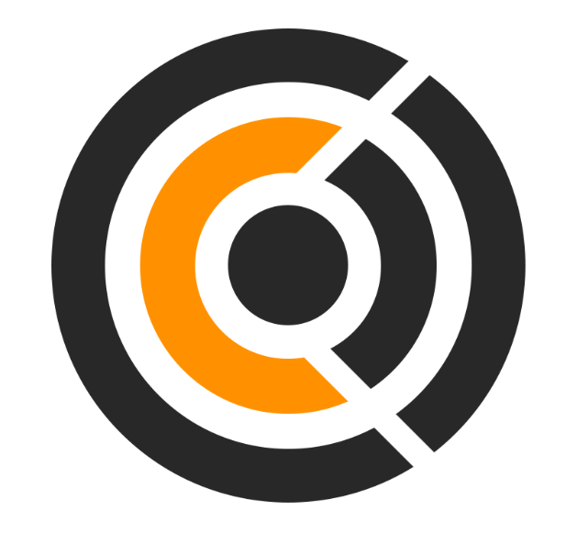

##### Symbolism

The thought behind this logo is as follows:

The circle in the center represents the user. Around the circle in the middle is a yellow ring. This ring represents people from different cultures (and thus is represented by a different color). The user doesn’t know these people yet, because he only ever interacts with the people within his radar (the two half rings to the right). With the use of this app however, he can get to know these bright people, and can thus expand his circle of friends, which is represented by the outer ring.

##### Combination

To finish the logo, we decided to combine this logo with the one we made at the second sketch. We put the compact logo above the font-logo, so that we have both and can use them together and apart from each other.

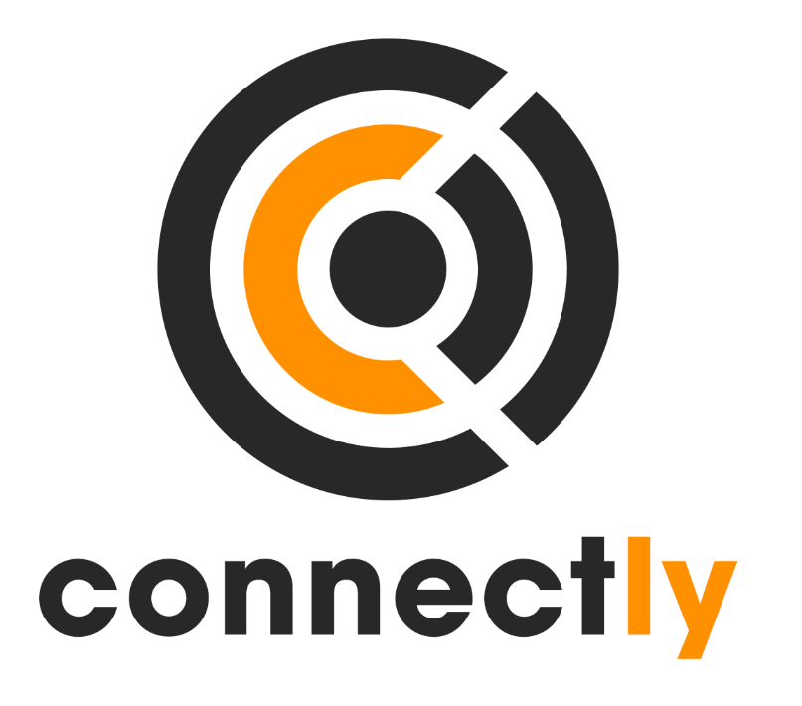

#### Version 2

##### Radar Concept

We decided to build on the previous concept a little more. For this version we tried incorporating the previous logo into a radar, since a radar is also a good way to show the user the people in your neighborhood that they can connect with. This way we could also make the C almost all the way around, to make it look a bit more like the C in the font-logo:

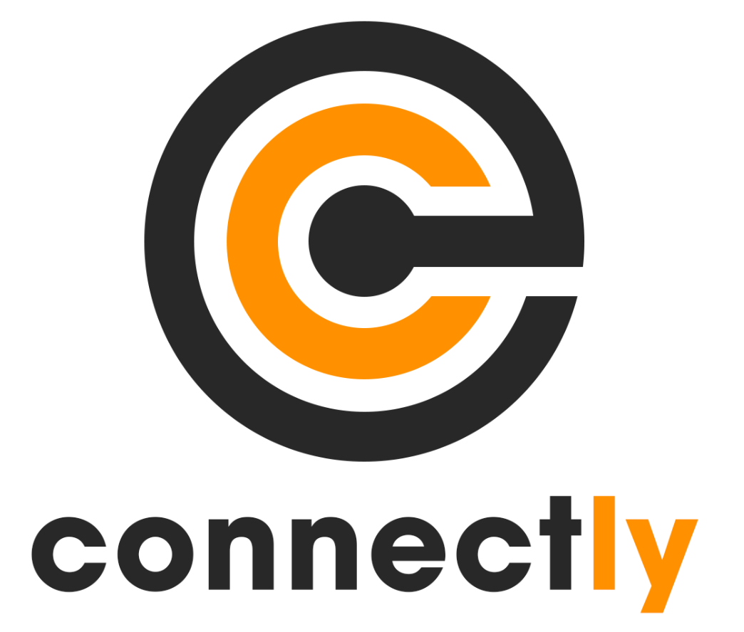

After some feedback we eventually decided to go with the first version, since most people we asked (including Olha) liked that one the most.

## 

## Personas

## 

## 

## 

## Scenarios

**Backstory**

Tom is from England. He likes to socialize and meet new people. He came to live and study in the Netherlands. However, since he is new, he does not really have any friends here. Tom used to play basketball with his friends in England and he really enjoyed it. There is a basketball court near to where he lives, but he does not live to play alone. He would like to get to know his neighbors, but he thinks it won’t be appropriate to go door to door and ask if someone wants to hang out with him or play basketball.

**Everyday Scenario:**

On the weekends, Tom would always use the app to check if someone posted any events that he might be interesting for him to attend. He notices there are football events that look interesting, but he would rather play basketball. Therefore, he creates an event with different timings that would be suitable for him and other people as well. He sees a lot of people are interested and then writes a comment on the event page that everyone should meet up at the time that most people chose. In the evening, everyone met up and had a lot of fun. Tom even made some new friends.

**Worst Scenario:**

Tom checks the app and sees there are no events this weekend. He decided to create an event to play basketball, but at the end of the day no one joined his event. He felt bad because he did not want to go play alone and ended up staying home.

**Ideal Scenario:**

Tom was very bored and it was a nice sunny day, so he registered in the app and checked how many people are on the app in a one kilometer radius around him Since he is new in the neighbourhood, he decided to check the events that are created already by people close by. He found someone created a basketball event and there was one last spot for a game, so he decided to join. He went on the time that was chosen by most people in the comments and had a lot of fun.

**Golden Plate Scenario:**

Tom checked the different events in the app, and he chose the category of basketball since he loves to play. Last week, he met one of his neighbors David and they played basketball for hours, so he was hoping to play with him again. He saw David already made an event for basketball and decided to join. He noticed there were some more new neighbours joining as well that he and David have never met. At the end of the day, David and Tom had an opportunity to meet their other neighbors and bond with them.

## 

## Use cases

Use Case Name: Join Event

Use Case Description: After the user joins an event. The user will be provided with information when the event will take place and how many neighbors joined that event.

Actors:

* Logged in User (user select event section)
* System (shows information to user)

Triggers:

* The user clicks the join button on the event he is interested in.

Preconditions:

* The user has sorted the events by selected category.

Post-conditions:

* The user will be informed about the event that he or she joined.
* The user selects one of the given time slots.
* The selected event that the user joins increases the count of people that joined the event.

Normal Flow:

1. The user will click the “Events” button.
2. The system will show existing events.
3. The user selects an event.
4. The system will show tips about the different countries of that event.
5. The system will show time slot selection.
6. The user selects on the preferred time slot.
7. The user clicks the join button
8. The system adds users to the event participant list.
9. The system increases the count of people of that event.
10. The system registered users as a subscriber to that event.
11. The system sends a notification 30 minutes before the event starts to the subscribed users.
12. After the event is done, the system will show past events and remove them from events history/list.

Alternate Flows:

3A1: User selected the wrong event.

1. The user will click the “x” button to close the selected event pop up.
2. The use case continues at step 2.

9A1: User decides that he doesn’t want to go to the event

1. The user clicks on the event
2. System pops up a window with information about event and button “Quit event”
3. The user clicks the “Quit event” button.
4. The system removes the user from the event and from the subscriber list.
5. The system decreases the count of participants of that event.

The use case continues at step 2.

# 3. Technical Documentation

## Feature list / Requirements

We made a requirements list for the project. The requirements are based on the MoSCoW method. In this method the M is for Must, S for Should, C for Could and W for Won’t. Priority is in the same order.

These are the requirements:

**Must have**

**M1. The system has an ability to register an user account.**

**M2. The system is able to authorize the user**

**M3. The user is able create an event**

**M4. The user is able to join an event.**

**M5. The system is able to choose a category for the particular event.**

**Should have**

**S1. The system has a feature which gives the user the ability to see other users in a range of x meters. This feature also shows the nationalities of the users.**

**S2. The user can translate the posts in the language they would like.**

**S3. The user is able to comment on an event.**

**S4. The user can sort the events by the category he/she prefers.**

**Could have**

**C1. The system has a build in event which is a city tour.**

**C2. The system has a rating feature where users can be rated on how helpful they are.**

**C3. The user can translate the posts in the language they would like.**

**C4. The system has a feature where users can ask for help.**

**C5. The user provides different timings for an event he/she makes, and others can vote for time best suitable for them.**

**Won’t have**

**W1. The system has a chat feature which gives users the option to chat with each other.**

## Entity Relations Diagram

We made an ERD diagram. In this diagram the database relations are described.

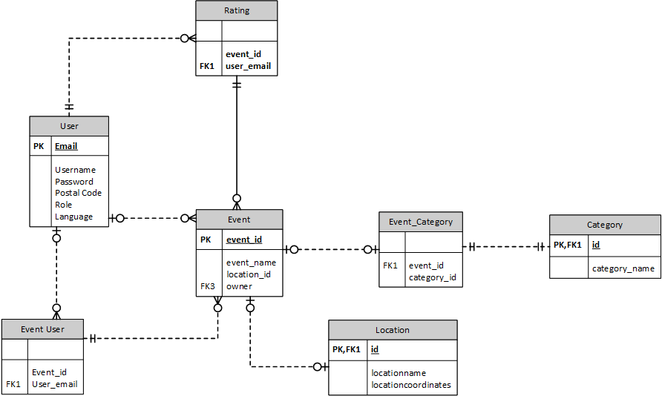

## Architecture

For the developing environment we created the following situation.

Database: Postgres database hosted by Heroku.

Backend: Java Springboot application with JPA. Hosted on Heroku. Master branch will trigger Heroku to build. Communication with front- and backend in JSON format.

Frontend: ReactJS hosted on a local machine. Connected to a backend hosted on Heroku.

Communication between front- and backend in JSON format.

## 

## 

# 5. Personal Reflections

## Niray

I think the start of this project was not so good. I think we should have spent more time discussing the concept and maybe we should’ve come up with better research questions. I think the main problem was the communication between the client. For me personally, it was not very clear what the client exactly wanted. I think we should have started thinking about questions for the client to make the problem a bit more clear. Perhaps this all also had something to do with the COVID-19 virus.

After the concept phase things were going a bit better. We all knew what we had to do because we used the Trello planning board a bit better.

I think it was also good that we started a bit earlier on developing the backend so the endpoints were available when we started on the frontend.

## 

## Gijs

We started on the project really fast even thought we had to communicate online because of COVID-19. We spend a lot of time brainstorming and coming up with ideas, from those ideas we created a demo, and presented it to the client. I think it would’ve been much easier if we could discuss with the client in real life instead of online.

After discussing with the client and changing the ideas to her wish we started planning and dividing the tasks through trello. This worked really good for us and I have the idea everybody did almost the same amount of work.

We spend a lot of time trying to get appsemble running and develop blocks for appsamble, after a few weeks we concluded that appsamble wasn’t developed far enough for our project.

I think that the overall project was good, I didn’t have trouble with anybody so that’s a good thing.

## 

## Nidhi

I think at the beginning of the project we all had some good ideas and had some really interesting brainstorming sessions. We definitely should have contacted the client at the beginning to share our ideas in order to prioritize our app functionalities and know her opinion on what she thinks before we presented it as a demo and did our research. I guess communicating face to face with the client would have been much more efficient than online communication.

After we were sure of our concept and talked it over with the client. We all knew what to do and divided the tasks really well using our project management tool.

Overall, I think the project went really well and had no issues working with anyone. I definitely learned a lot from everyone in this group. For the future I think we should do some research in the type of framework that everyone is familiar with and we all can use to develop a more efficient app.

## Dary

In this project I increased my mobile designing skills. I've looked a lot at the material design guidelines and tried to implement it. This was the first time i really used and looked at a professional design guideline.

Also in this project I used a front-end framework for the first time ever. The framework we used is React. It was very hard to work with React in the beginning but i got some good help from Niray.

I think we didn't had enough time for this project. But we did stick to long on the designing fase because we changed our concept a little bit.

Next time we or I need to keep more contact with the stakeholder. I was the project leader and I didn't communicate with the stakeholder enough.

I was the projectleader in this project and I think I did a pretty good job having that role. I communicated good with the group.

Overall the project went well and the communication was good. Though I really wanted more time to finish everything since we haven't fully programmed and added every feature

## Finn

I learned a lot about working with a stakeholder during this project, which I think is a very useful and applicable skill to have. It was a lot of fun to work with a group of people from all sorts of different personal and professional backgrounds. It is nice to have a mix of software students and media students, so you can get input from both a design and a programming perspective. This way you can get the best of both worlds from people who know what they are doing.

I also learned a lot of new things about the design of an app, and in particular material design.

I personally think I had a good impact on the design aspect of the project. I was very glad with the final result of the logo that I worked on, since I made a lot of iterations that took a lot of time, so to see that working out into a good looking logo is really rewarding.

I also think I had a good impact on the app designs, and think the final results looked very good.

I think I could do a bit better on the ‘waking up’ part of the project. I had quite a lot of bad nights sleep, that made it so I would quite often be 10-15 minutes late to the morning call. I do feel like I kind of made this right by working extra hard at the end of the day however, so I still did my part pretty well.

I also think I could have done slightly better on the communication part of the project, since the group often didn’t quite know what I was working on. This is definitely something I need to work on in the future.

## 

## Edgaras

**Strong/Weak traits that affected the project**

One of the weakest traits that affected the project would be COVID-19, because of them we had unusual experience that caused communication problems. However, despite that our work division was strong and overall, we managed to compliment communication issues with getting used to that and by sharing screens to help teach others.

**Learning moments from the project**

We decided to use the React JS framework despite the fact that I never used the React JS framework before. It was a nice experience to explore and learn to use it for our project. Improved my research skills even further. Learn to work in a group of 6 people that is really something different from working in pairs.

**Evaluation of spent effort**

I, like the rest of my group, spent a lot of time, and as efficiently as I could, worked a lot with concepting for our application. Also I put a lot of effort to learn React JS on my own time, so I could apply it during project time.

**Improvements for the next project (what could you do better next time)?**

For next time I would choose better research questions. And maybe use tools that I and most of my teammates are most familiar with in order of faster and more efficient development.

# 

# 6. Peer Reviews

## Niray

**Gijs:**

I think Gijs did a great job together with me in developing the backend. Together we created the backend fast and it’s also pretty clean code. After this we started helping the frontend with linking front- and backend together. You also did implement some PWA features.

**Nidhi:**

Very involved in the project. Also I got the idea you picked up React pretty quickly. You also tried to help the team with the knowledge you had from last semester which was great.

**Dary:**

Good job on designing. You and Finn made some nice wireframes, logos and designs. Also cool that you joined on developing the frontend. I guess that was not easy for you. I think you also did a good job on communicating within the team. Good project leader. Tip for next time: communicate everything with the client.

**Finn:**

I think you did a great job on designing the logo and the style guide together with Dary. I can see that you guys have quite some experience in designing. I think you were late too often. You only informed us like one time about being late. Also sometimes I had no idea what you were working on.

**Edgaras:**

Very involved in the project. You came up with many ideas to solve the problem and think about a lot of things like: cultural and language barrier. I also think you are very studious. Nice to have you in the team.

## Gijs

**Niray:**

Niray really did a good job working on the backend; he set up the architecture which was looking really clean. We tested out appsemble and came together to the conclusion that appsamble wasn’t suitable for our project. We worked together on a function for the backend which we finished really fast. He also helped almost everybody with understanding the react framework. He also always has a good vision on what has to be done and what needs to be done. Overall I think Niray is a really useful team member!!

**Nidhi:**

Nidhi did a really great job on the designs, worked together with me on personas, use cases and backstories. She explained to me a lot about UX which I was having a hard time with understanding. She also worked a lot on the frontend together with Edgaras, where she is really good at. She understood react really fast and is always helpful to other team members.

**Dary:**

Dary did a lot of UI design together with Finn this is probably because he has a media background I learned a lot of Dary on how to design UI, he has a clear english voice and is really good understandable, which is nice. When I needed help with Media things I always could ask Dary and he would help me out. He also designed a cool logo together with Finn.

**Finn:**

Finn did a lot of UI design just as Dary, this is because they both have a media background. They really did a good job designing the logo as well. The last few weeks he was a little bit later then everyone but he did his work so that’s fine for me.

**Edgaras:**

Edgaras is a really helpful team member as well, he has a good vision on what has to happen and takes the lead, this makes him a really suitable team member. He also did a lot of work on the front-end as well on the design part.

## Nidhi

**Niray:**

Helped me a lot with react and answered my questions whenever I needed help with something. Took initiative in the project and guided everyone. Did a really good job in the backend.

**Gijs:**

Always gave his input for the project and did a good job in the backend and explained to me whatever needed clarification.

**Dary:**

Made some great designs and helped everyone else in the group out. Good job on developing on the front end part as well. I think you also did a good job on communicating within the team. Great project leader.

**Finn:**

Great job on the designs and logo. Always gave feedback to everyone and your input. Maybe next time just communicate better with the group.

**Edgaras:**

Worked on research and react with me and that went very well. Great job on the front end developing and giving ideas for the application. Taking initiative and making sure everyone knows what to do.

## Dary

**Niray:**

Niray surprised me everything when he shows his progress on the back-end but also on the front-end. Niray has done a lot of work on the development part and was able to help me out a lot with React.

**Gijs:**

Also has done a very good job on the back-end. Gijs wanted to learn more about designing and UX so he helped me Nidhi and Finn out with designing the app and made his own iteration.

**Nidhi:**

Sometimes a little quite but always does her job. Also Nidhi worked very hard on the front-end and she made the first wireframes. Those wireframes led to the final designs. So a thumbs up to Nidhi.

**Finn:**

Sometimes a little bit late in the morning but has still done a great job on designing the app together with me and Nidhi.

**Edgaras:**

Edgaras did a lot of the concept thinking in the beginning. He came up with the first concept and changed it later. Furthermore Edgaras also did a good job on working on the front-end

## Finn

**Niray:** Niray is a very solid back-end developer and definitely knows what he is doing when it comes to that. He has a very good impact on the project.

**Gijs:** Also knows a lot about back-end development, but what I really liked about him was that he also wanted to learn a lot about UI and UX development. He definitely helped us out well on this aspect.

**Nidhi:** Surprisingly knows a lot about UI and UX and did a great job on the wireframes of the app, that eventually became the actual designs.

**Dary:** Did a lot on the UI design and front end development of the app. He is a very experienced Adobe Xd user and knows how to make things look good.

**Edgaras:** Always brings a positive attitude to the group, and does a lot of documentation and concepting. He also is a very good brainstormer, and can come up with a lot of good ideas in a short amount of time.

## Edgaras

**Niray:** Working hard and efficiently on backend together with Gijs and helping a lot with React Js, because he had experience with it. And overall very active and helpful.

**Gijs:** Working on backend together with Niray and did a good job on that. Made design for creating an event page very well.

**Nidhi:** Worked hard on personas, use cases and backstories. She has good knowledge of UX. Doing a great process using React JS framework for the first time, active and learned quickly. Also helps a lot with documentation.

**Dary:** Put a lot of effort on frontend have advanced skills of javascript and css. Very helpful help everyone and even tho have a lot of struggle using React JS still works hard and asks help when needed and manages everything. And even works extra during his free time.

**Finn:** Worked with a design document and logo and did a good job on that. Were late time by time, but most cases informed us about it and it didn’t affect the project much.